**Name:** Abhishek Kaudare **Roll No.:**31

**1)Python program to check if number is positive,negative or zero**

**Code:**

num=int(input("Enter the number to be checked: "))

if num>0:

print(num," is positive")

elif num<0:

print(num," is negative")

else:

print(num“ is zero")

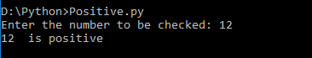

**2)Python program to check if number is even or odd**

**Code:**

num=int(input("Enter the number to be checked:-"))

if num%2==0:

print(" The Number",num ,"is even")

else:

print("The Number",num,"is odd")

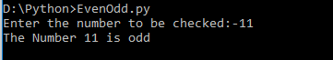

**3)Python program to check leap year**

**Code:**

num=int(input("Enter the number to be checked:-"))

if num%2==0:

print(" The Number",num ,"is even")

else:

print("The Number",num,"is odd")

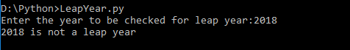

**4)Python program to find largest among three years**

**Code:**

num1=int(input("Enter the first number: "))

num2=int(input("Enter the second number: "))

num3=int(input("Enter the third number: "))

if num1>num2 :

if num2>num3:

print(num1," is greatest among",num1,num2,num3)

elif num3>num1:

print(num3," is greatest among",num1,num2,num3)

elif num2>num1:

if num1>num3:

print(num2," is greatest among",num1,num2,num3)

elif num3>num2:

print(num3," is greatest among",num1,num2,num3)

else:

print(num3," is greatest among",num1,num2,num3)

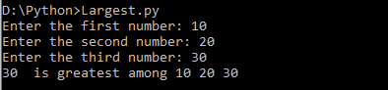

**5)Python program to check prime number**

**Code:**

i=int(input("Enter the number to be checked for prime: "))

j=2

while(j<=(i/j)):

if i%j==0:

break

j=j+1

if j>i/j:

print(i,"is a prime number")

else:

print(i,"is not a prime number")

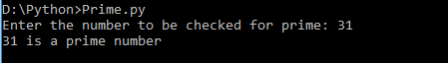

**6)Python program to check Prime number in an interval**

**Code:**

i=2

upperlimit=int(input("Enter the number upto which prime number is to be found: "))

while (i<upperlimit):

j=2

while(j<=(i/j)):

if i%j==0:

break

j=j+1

if j>i/j:

print(i)

i=i+1

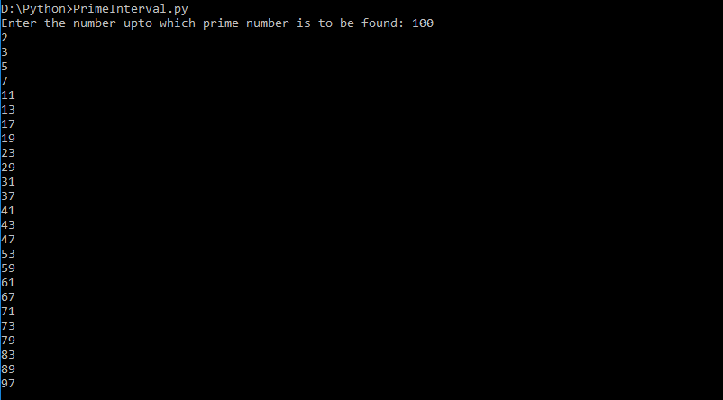

**7)Python program to find factorial of a number**

**Code:**

num=int(input("Enter the number whose factorial is to be found: "))

res=1

if num<0:

print("Factorial does not exist for negative numbers")

elif num==0:

print("The factorial of 0 is 1")

while(num!=1):

res=res*num

num=num-1

print("Factorial is ",res)

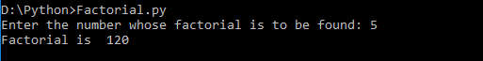

**8)Python program to display multiplication table**

**Code:**

num=int(input("Enter the number for multiplication table:"))

for i in range(1,11):

print(num,"*",i,"=",num*i)

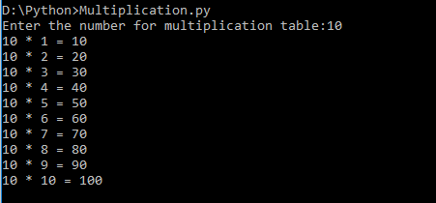

**9)Python program to print fibonacci series**

**Code:**

range1=int(input("Enter the number of elements of the series "))

n1=0

n2=1

i=2

if range1<= 0:

print ("Enter a positive integer: ")

elif range1== 1:

print ("Fibonacci series up to",range1,":")

print (n1)

else:

print ("Fibonacci series up to",range1,":")

print (n1)

print (n2)

while i<range1:

n3=n1+n2

print (n3)

n1=n2

n2=n3

i=i+1

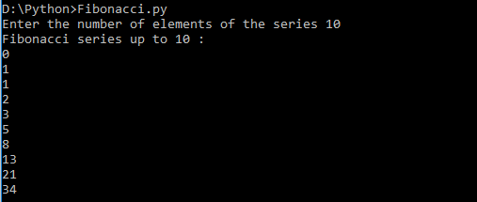

**10)Python program to check Armstrong number**

**Code:**

num=int(input("Enter the number to be checked if it is Armstrong: "))

temp=num

sum=0

while temp>0:

remainder=temp%10

sum=sum+(remainder**3)

temp//=10

if num==sum:

print(num,"is Armstrong number")

else:

print(num,"is not a Armstrong number")

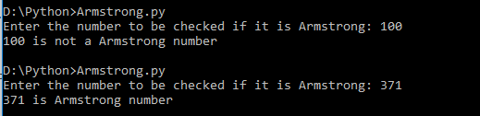

**15)Advanced bubble sorting using lists**

**Code:**

lis = [int(i) for i in input('Enter the elements: ').split()]

for i in range(len(lis)):

swap = False

for j in range(len(lis)-1):

if lis[j]>lis[j+1]:

lis[j], lis[j+1] = lis[j+1], lis[j]

swap = True

if swap==False:

break

#print('The sorted array is: {}'.format(' '.join(map(str, lis))))

print(lis)

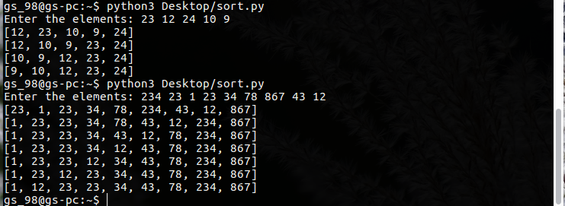

**16)Binary Search using lists**

**Code:**

lis = [int(i) for i in input('Enter the elements in ascending order: ').split()]

n = int(input('Enter the element to be searched: '))

lb, ub = 0, len(lis)-1

mid = int((lb+ub)/2)

while mid<=ub and lis[mid]!=n:

if n>lis[mid]:

lb = mid+1

else:

ub = mid-1

mid = int((lb+ub)/2)

if lb==ub:

break

if lis[mid]==n:

print('Element found at {} position'.format(mid+1))

else:

print('Element not found')

